ANSWER THESE COMPETENCY BASED QUESTIONS
Samples for PT 2

WRITE THE ANSWERS, DRAW THE SKETCHES IN YOUR NOTEBOOKS. Task for Monday – First and the second period.

Understand, what we study will differ when we apply it in subjects like ours. These are certain application based questions for all to attempt. It will surely check your understanding of a chapter or unit, and will also inform you how you can apply the same knowledge in further study of the subject.
Here you go!

Question.
- Name the type of advertising used here. Can you use the same medium to explain the same message but draw a different visual?

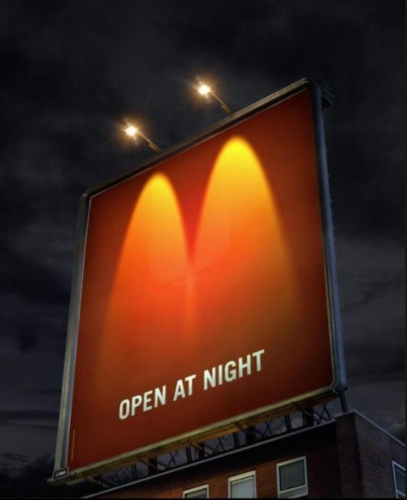

Question.
- To commemorate Earth Day, WWF introduced a series of advertisements to promote the fragility of our Earth. This creative advertisement example is an ideal juxtaposition of the world on an ice cream cone. The Earth acts as a scoop of ice cream with melted parts running down the side of a cone. Making the suggestion that the Earth is as fragile, and ‘throw away’ as a melting ice cream is hard hitting and works across all age groups.
TASK – Analyse the advert on the social cause/concern and pick any social concern to show the impact of the same, visually. You can use the same social concern but do it through a different visual. Before attempting the same, read the description of the ad above.



Question.
- This is a promotion of DHL delivery services – magazine ad. Check out how smartly they have conveyed their brand’s message. Can you pick out the message told here and how can you redo the same type of ad for Dominos pizza delivery which promises home delivery of pizzas in half n hour.

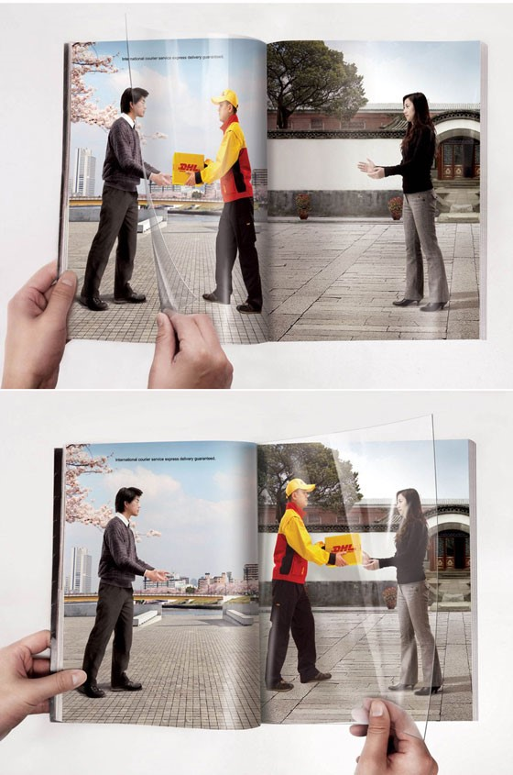

Question.
- Such social issues has always been advertised using strong, direct visuals. Pick any social issue of your choice, use the same layout shown below and plan the advertisement of the same. Check out one below –

Tagline here reads – Adopt. You will receive more than you can ever give.

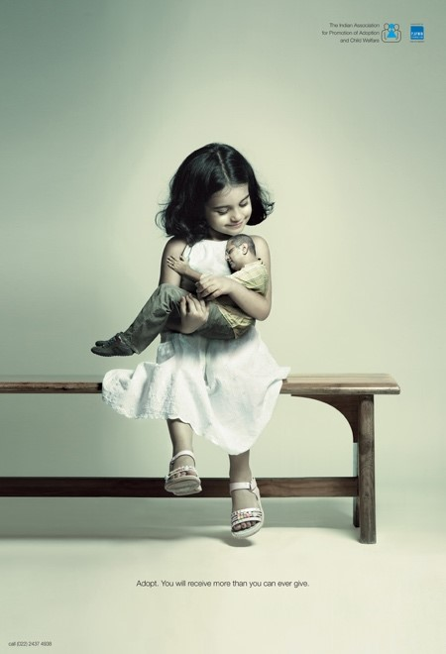

Task for Monday – Zero period

- Complete your portfolio work.
- Plan and complete the ideation part of the website and the magazine.
- You can brainstorm together, but everyone will work individually on their own project.
- The magazine can be of 6-10 pages. The topic can – fashion, sports, automobiles, famous personalities, music, rock bands, business news, interior design, furniture, any brand’s new product launch, you as a brand, school magazine.
- Website brands can be – Watch, cars, bikes, sportswear, sports apparel, etc.

